Aim: To perform Graphical Exploratory Data Analysis.

Dataset:
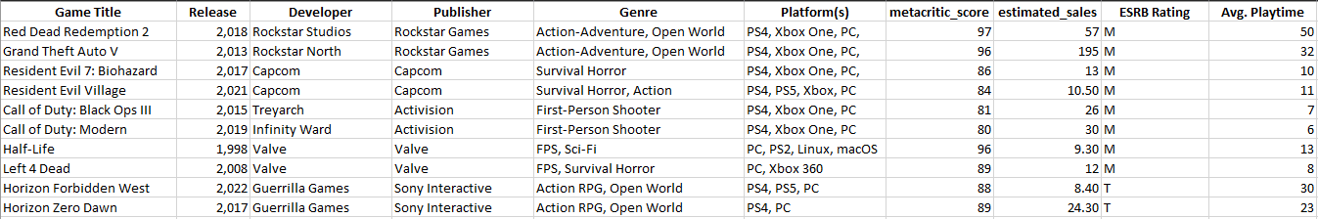

Loading the Dataset:
import matplotlib.pyplot as plt
import numpy as np
import pandas as pd
import seaborn as sns

df = pd.read_excel('AIDS-1EXP3.xlsx')

print("Dataset Info:")
print(df.info())
print("\nFirst few rows:")
print(df.head())
print("\nColumn names:")
print(df.columns.tolist())

Output:

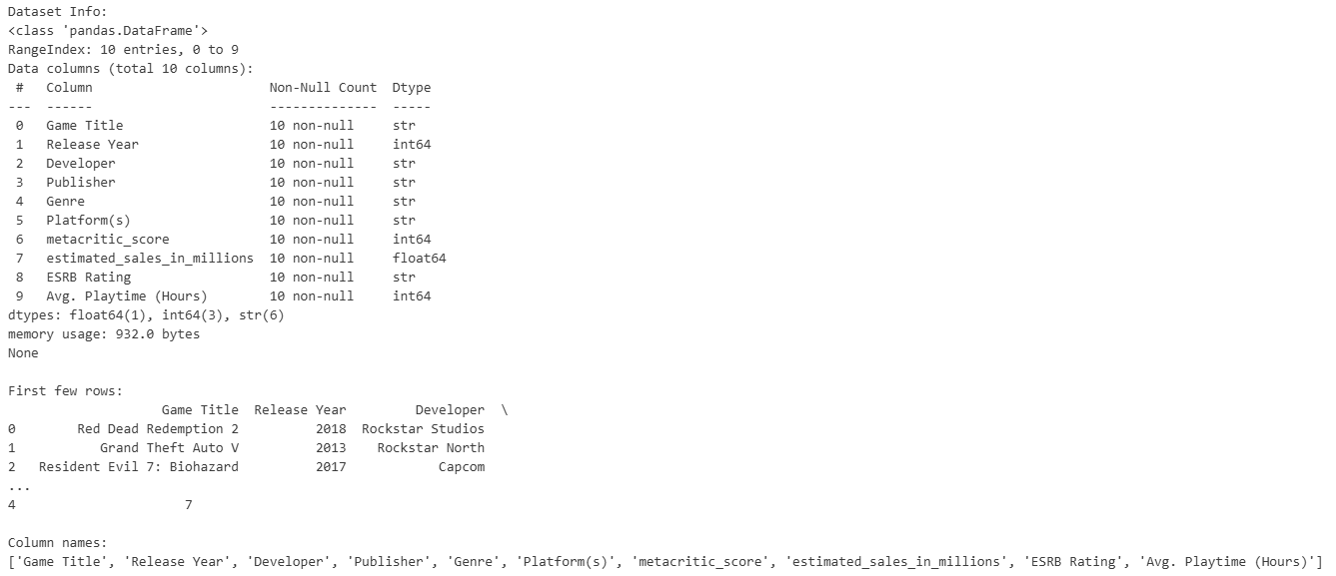

What is a Histogram?
A histogram is a chart that plots the distribution of a numeric variable's values as a series of bars. Each bar typically covers a range of numeric values called a bin or class; a bar's height indicates the frequency of data points with a value within the corresponding bin.

fig = plt.figure(figsize=(20, 16))

ax1 = plt.subplot(2, 2, 1)
ax1.hist(df['metacritic_score'], bins=8, color='skyblue', edgecolor='black', alpha=0.7)
ax1.set_xlabel('Metacritic Score')
ax1.set_ylabel('Frequency')
ax1.set_title('Distribution of Metacritic Scores', fontsize=14, fontweight='bold')
ax1.grid(True, alpha=0.3)

Ouput:

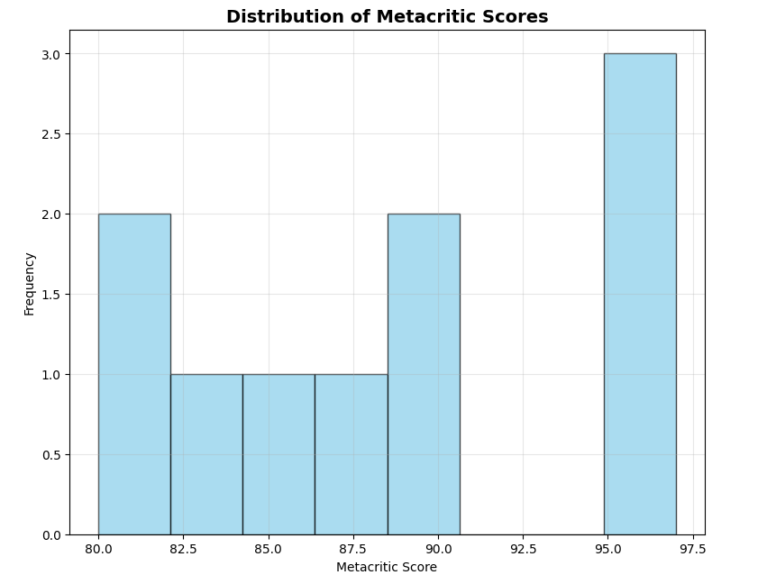

What is a Scatter Plot?
Scatter plots are the graphs that present the relationship between two variables in a data-set. It represents data points on a two-dimensional plane or on a Cartesian system. The independent variable or attribute is plotted on the X-axis, while the dependent variable is plotted on the Y-axis.
mean_score = df['metacritic_score'].mean()
median_score = df['metacritic_score'].median()
ax1.axvline(mean_score, color='red', linestyle='dashed', linewidth=2, label=f'Mean: {mean_score:.1f}')
ax1.axvline(median_score, color='green', linestyle='dashed', linewidth=2, label=f'Median: {median_score:.1f}')
ax1.legend()

ax2 = plt.subplot(2, 2, 2)

colors = {'M': 'red', 'T': 'blue'}
for rating in df['ESRB Rating'].unique():
mask = df['ESRB Rating'] == rating
ax2.scatter(df[mask]['metacritic_score'],
df[mask]['estimated_sales_in_millions'],
c=colors[rating],
label=f'ESRB {rating}',
s=100,
alpha=0.6)

Ouput:

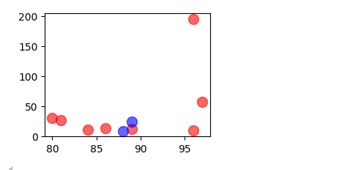

What is a Bar Graph?
A bar graph (or bar chart) is a visual tool that uses rectangular bars to represent and compare numerical data across different categories.

ax2.set_xlabel('Metacritic Score')
ax2.set_ylabel('Estimated Sales (Millions)')
ax2.set_title('Metacritic Score vs Estimated Sales', fontsize=14, fontweight='bold')
ax2.legend()
ax2.grid(True, alpha=0.3)

z = np.polyfit(df['metacritic_score'], df['estimated_sales_in_millions'], 1)
p = np.poly1d(z)
ax2.plot(df['metacritic_score'].sort_values(),
p(df['metacritic_score'].sort_values()),
"r--", alpha=0.8, label='Trend Line')

ax3 = plt.subplot(2, 2, 3)
top_games = df.nlargest(10, 'estimated_sales_in_millions')

bars = ax3.barh(range(len(top_games)), top_games['estimated_sales_in_millions'].values)
ax3.set_yticks(range(len(top_games)))
ax3.set_yticklabels(top_games['Game Title'].values, fontsize=10)
ax3.set_xlabel('Estimated Sales (Millions)')
ax3.set_title('Top Games by Estimated Sales', fontsize=14, fontweight='bold')

for i, (bar, sales) in enumerate(zip(bars, top_games['estimated_sales_in_millions'].values)):
ax3.text(sales + 1, bar.get_y() + bar.get_height()/2, f'{sales:.1f}M',
va='center', fontweight='bold')

Ouput:

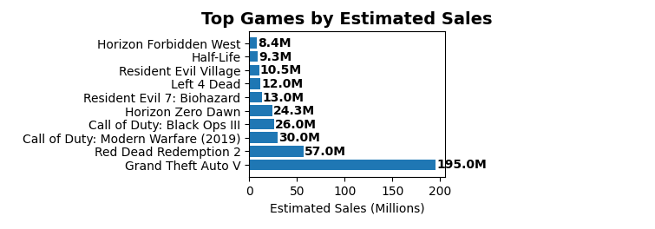

What is a Heatmap?
A heat map is a data visualization technique that represents the magnitude of data points through colors, typically arranged in a 2D grid or map format. Using a spectrum—often warm colors (red/orange) for high intensity and cool colors (blue/purple) for low intensity

colors = plt.cm.viridis(np.linspace(0.2, 0.9, len(top_games)))
for bar, color in zip(bars, colors):
bar.set_color(color)

ax4 = plt.subplot(2, 2, 4)

numeric_cols = df.select_dtypes(include=[np.number]).columns
correlation_matrix = df[numeric_cols].corr()

im = ax4.imshow(correlation_matrix, cmap='coolwarm', aspect='auto', vmin=-1, vmax=1)

for i in range(len(correlation_matrix.columns)):
for j in range(len(correlation_matrix.columns)):
text = ax4.text(j, i, f'{correlation_matrix.iloc[i, j]:.2f}',
ha="center", va="center", color="black", fontweight='bold')

ax4.set_xticks(range(len(correlation_matrix.columns)))
ax4.set_yticks(range(len(correlation_matrix.columns)))
ax4.set_xticklabels(correlation_matrix.columns, rotation=45, ha='right')
ax4.set_yticklabels(correlation_matrix.columns)
ax4.set_title('Correlation Heatmap of Numeric Variables', fontsize=14, fontweight='bold')

plt.colorbar(im, ax=ax4, fraction=0.046, pad=0.04)

plt.suptitle('Game Industry Data Analysis Dashboard', fontsize=16, fontweight='bold', y=1.02)
plt.tight_layout()
plt.show()

Ouput:

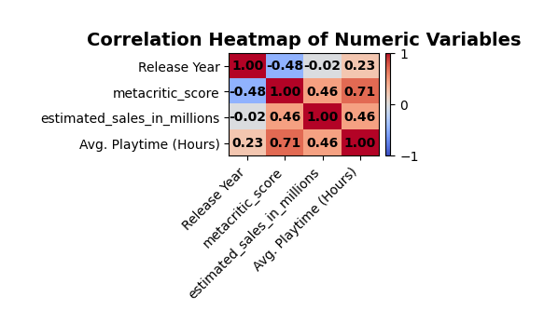

Conclusion
Successfully demonstrated four key data visualization techniques - histogram, scatter plot, bar chart, and heatmap - enabling effective graphical exploratory data analysis and pattern identification in the dataset.

